CHAPTER 2
LITERATURE REVIEW

Theoretical Basis

Social Media

Social Media in Indonesia
Social media is defined as a representation of the technologies or applications that individual use for creating and maintaining their social networking sites (Albarran, 2013, p. 2). A study proposed a framework which divides the functionality of social media into seven blocks (Kietzmann et al., 2011, p. 241). One of these blocks is the identity block. The identity block represents the identities which are revealed through social media. By revealing different sorts of data on their social media accounts, one can learn and extract different kinds of information.

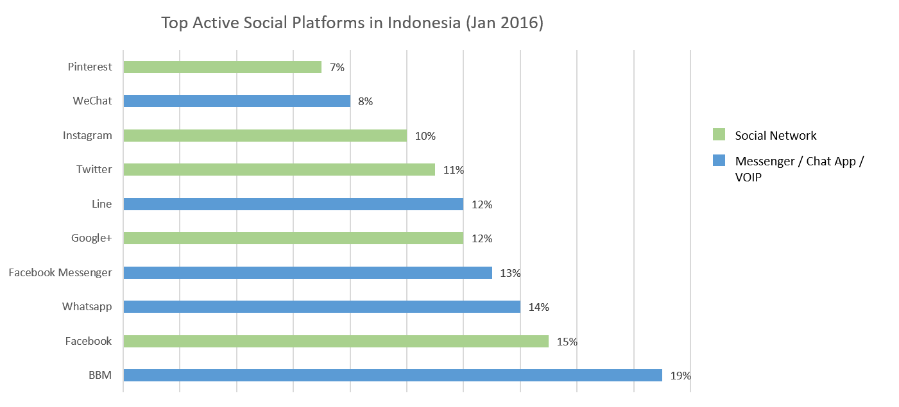
Figure 2.1 Statistic of Social Media and Applications Chat Usage in Indonesia in January 2016
(Source: Kemp, 2016, p.224)

Figure 2.1 is a graph showing the top 10 social platforms used in Indonesia as of January 2016. As depicted in Figure 2.1, Facebook, Google Plus, and Twitter are the top 3 social media platforms used in Indonesia.
Indonesia has a population of approximately 260 million people, 88 million people among them are active Internet users and 79 million people are active social media users (Kemp, 2016, p. 215). These statistics show that Indonesia has a high rate of social media usage.
Combining these facts show that there is potentially a considerable amount of information that can be extracted from Indonesian social media users. The extraction of information from social media can yield accurate and insightful results if done correctly, which is why this is a potential area of research, as more methods still need to be explored to perfect said task.

Use of Social Media
Social media is a platform where users are able to share content, communicate, or discuss about a certain topic (Kietzmann et al., 2011, p. 243-248). A previous study proposed a honeycomb framework on the 7 functionalities of social media.
- Identity
Identity represents the act of users revealing information about themselves on social media. Revealed information may be disclosed consciously by users through profile information or unconsciously through other information that describes their personality.
- Conversations
Conversations represents the communication between users on social media. Conversations on social media can take place for various reasons such as discussing new ideas, trending topics, or finding like-minded people.
- Sharing
Sharing is the act of exchanging, distributing, and receiving content. Users on social media aren’t always connected by communication, as it depends on the reasons they associate with each other. Instead, social media users are connected to one another by a shared object.
- Presence
Presence refers to how accessible a certain user is to other users. Accessibility on social media is defined by knowing where other users are, and whether they’re available at that moment.

- Relationship
Relationship represents the extent of users to be related to other users. The connection of users on social media determine what and how information exchange is done.
- Reputation
Reputation is the act of identifying the standing of social media users. Reputation has different meanings in different social medias. For example, reputation on YouTube is based on the number of likes and view counts, whereas reputation on LinkedIn is built on endorsement by other users.
- Groups
Groups represent the extent of users forming a community or sub-community. The bigger the group of friends, the more ‘social’ the network is.

Twitter
Twitter is a social media where users are allowed to publish posts in a maximum of 140 characters which are usually referred to as tweets. It is considered as a microblogging social media due to its nature of posting short and frequent posts (Java, Song, Finin, & Tseng, 2007, p. 56).
The several features available on Twitter as listed on the official Twitter support website (Twitter Inc., n.d.) are as follows.
- Tweets
A tweet is a short post that is made by the user consisting of a maximum of 140 characters.
- Home timeline
Home and feeds are a collection of tweets showing the top and latest tweets made by other accounts followed by the user.
- Notification
Notification is a list of latest activity that shows information related to the user such as latest mentions, latest followers, latest retweets, and latest likes.

- Direct messages
Direct messages are private messages sent from one user to another which don’t appear in the home timeline. It can only be seen by the sender and the recipient. Direct messages can only be sent to another account who is following the user.
- Following
The following feature is the list of accounts followed by the Twitter user.
- Followers
The follower feature is the list of accounts following the Twitter user.
- Retweets and Quote tweet
Retweets and quote allows Twitter users to share original tweet written by other users. Retweets allow users to share the content without adding their own comment, while quote allows users to add their own additional comment regarding the shared content.
- Reply
The reply feature allows users to respond to another separate tweet.
- Mention
A mention is a tweet that enables Twitter users to converse with other users. A mention is done by using the “@” symbol, followed by the username of the account the user wants to converse with.

Twitter has about 310 million active users each month and approximately 140 million tweets are posted each day (Twitter Inc, n.d.). The large amount of tweets containing various subjects make Twitter an interesting material for academic research (Lee, Leung, Qiu, & Chu, 2013, p. 230). Several studies have been conducted to process Twitter data, such as sentiment analysis to evaluate whether a tweet contains positive or negative meaning (Pak & Paroubek, 2010, p. 1321), analyzing whether tweets reflect differences between Democrat and Republican Twitter users (Sylwester & Purver, 2015), and personality prediction (Celli, 2011, p. 1-5). Several researches that have been conducted on Twitter will be further discussed in section 2.2.

Twitter API
Information on Twitter is accessible through the Twitter APIs (Kumar, Morstatter, & Liu, 2014, p. 3). A Twitter API is a service which allows developers to read or write Twitter data such as creating a new tweet, retweeting, reading user data, reading follower data, etc. Twitter provides programmatic access through REST APIs and Streaming APIs. The REST API uses the pull strategy for data retrieval, where retrieving data from Twitter requires explicit request from the developer. On the other hand, the Streaming API uses the push strategy for data retrieval, where a continuous stream of updates is provided for the developer after one request. Responses from both APIs are in JSON format.
Since the Twitter API is merely used to retrieve user’s Twitter information, the type of Twitter API used in this study is the REST API.

Twitter4j
Twitter4j is an open source Java library for Twitter APIs (Pedrycz & Chen, 2013, p. 404). This library simplifies the integration of Java applications and the Twitter service. What was once returned as a JSON format from the original REST Twitter API has been modified to functions which can be called to retrieve a certain type of information. The library is based on Java language, which is supported by Android devices. It has access to various resources such as timeline, tweet, user, friends and followers, friendship, account resources, trends resources, and search API resources.

Language in Social Media
Social media allows different kinds of casual and interpersonal interaction with other users (Zappavigna, 2012, p. 127). This allows users to chat with other users in an informal way, in other words using slang language. Slang language plays a role in the community’s solidarity and affiliation between users.
Slang language are creative expression towards language to make words simpler and efficient to be spoken. This is especially common on microblogging social medias, as users are generating micro-posts along with their other activities. As a result, they tend to quickly think up of linguistic resources which can be used to convey his/her point (Zappavigna, 2012, p. 150). Because of this, time plays an important role in the development of slang language (Gemilasari, Jufrizal, & Hafizh, 2013, p. 143).

Personality

Definition of Personality
Personality is defined as behavior patterns and intrapersonal processes of each individual (Burger, 2015, p. 4). Personality also refers to individual visible characteristics that other people can see (Schultz & Schultz, 2009, p. 8).
There were several personality studies by scientists conducted over the years, thus resulting in different kinds of personality theories. Some notable proposed personality models are described in the next section.

Personality Models

Cattel’s 16 Personality Factors
Cattell’s 16 Personality Factors was proposed by Raymond B. Cattell in 1965. The 16 personality factors are used to describe people. The personality factors presented are associated with the words used in describing friends and ourselves through daily conversations (Schultz & Schultz, 2009, p. 268). These factors are obtained using 3 kinds of information, which are life records (L-data), questionnaires (q-data) and personality tests (t-data). The 16 personality factors proposed are as follows (Hersen, 2004, p. 40).
- Abstractedness: imaginative versus practical
- Apprehension: worried versus confident
- Dominance: forceful versus submissive
- Emotional Stability: calm versus high strung
- Liveliness: spontaneous versus restrained
- Openness to Change: flexible versus attached to the familiar
- Perfectionism: controlled versus undisciplined
- Privateness: discreet versus open
- Reasoning: abstract versus concrete
- Rule-Consciousness: conforming versus non-conforming
- Self-Reliance: self-sufficient versus dependent
- Sensitivity: tender-hearted versus tough-minded
- Social Boldness: uninhibited versus shy
- Tension: impatient versus relaxed
- Vigilance: suspicious versus trusting
- Warmth: outgoing versus reserved

Eysenck Personality Inventory
The Eysenck Personality Inventory was presented by Hans Eysenck and Sybil Eysenck. After 12 years of research, they were able to come up with three dimensions of personality (Schultz & Schultz, 2009, p. 278). The three personality dimensions are as follows.
- E – extraversion versus introversion
- N – neuroticism versus emotional stability
- P – psychoticism versus impulse control
The traits proposed in the Eysenck Personality Inventory tend to remain stable over time, from childhood to adulthood (Schultz & Schultz, 2009, p. 279). For example, an introverted child has the tendency to remain introverted during his adulthood.

The Five Factor Model
The Five Factor Model, or commonly referred to as The Big Five, was proposed by Robert McCrae and Paul Costa. The Five Factor Model was studied through several assessment techniques, such as self-ratings, objective tests, and observers’ reports. Two kinds of personality tests were developed, which are the NEO Personality Inventory (NEO PI-R) consisting of 240 items and a revised version of the NEO PI-R consisting of 60 items.
- Openness to Experience
Openness to Experience is a personality trait which assesses an individual’s appreciation and toleration for unfamiliar experience (Cervone & Pervin, 2013, p. 265). An individual with high Openness trait is usually artistic, curious, insightful, original and has wide interests, unusual thought processes and intellectual interests.
- Conscientiousness
Conscientiousness is a personality trait which evaluates how organized, persistent, and goal-directed or motivated an individual is (Cervone & Pervin, 2013, p. 265). People with high conscientiousness traits are usually efficient, organized, planful, reliable, thorough, dependable, ethical, and productive.
- Extraversion
Extraversion is a personality trait which identifies the amount and intensity of an individual’s interpersonal interaction, activity level, need for stimulation, and capacity for joy (Cervone & Pervin, 2013, p. 265). High extraversion is characterized with people who are active, assertive, energetic, outgoing, talkative, gesturally expressive, and gregarious.
- Agreeableness
Agreeableness is a personality trait which measures the interpersonal orientation of an individual in terms of thoughts, feelings and actions(Cervone & Pervin, 2013, p. 265). Individuals with high agreeableness trait are usually appreciative, forgiving, generous, kind, trusting, noncritical, warm, compassionate, considerate, and straightforward.
- Neuroticism
Neuroticism is a personality trait which identifies how well a person is able to adjust his/her emotions (Cervone & Pervin, 2013, p. 265). High neuroticism individuals are commonly anxious, self-pitying, tense, emotionally unstable, impulsive, vulnerable, touchy, and prone to worry. The opposite of neuroticism is emotional stability where individuals are calm, unemotional, and self-satisfied (Huver, Otten, de Vries, & Engels, 2010, p. 396).
Previous studies on The Five Factor model show that the rate of these personality traits can indicate a person’s life outcomes (Roberts et al., 2007, p. 339). Besides describing a person’s characteristics, The Five Factor personality model can also be used to predict the performance of individuals, parenting style, psychological disorders, level of happiness, and academic achievement (Cacioppo & Freberg, 2012, p. 583).

Natural Language Processing

Definition of Natural Language Processing
Natural language processing is a field where an agent performs knowledge acquisition by making use of abundant amount of knowledge expressed in natural language (Russell, Norvig, Canny, Malik, & Edwards, 2010, p. 860). Natural language is a language used by humans as a means for communicating. Natural language processing is a difficult task because human language tends to be ambiguous and messy. It differs from other types of data processing systems because it requires knowledge of language to complete its task (Jurafsky & Martin, 2009, p. 2). There are 7 different levels of linguistic analysis (Liddy, 1998, p. 14-15). The 7 different levels are as follows.
- Phonological level
Phonological level refers to the knowledge on how words are pronounced.
- Morphological level
Morphological level refers to the knowledge about components of a word, such as prefixes, suffixes, and roots.
- Lexical level
Lexical level refers to the word level knowledge of a certain word, such as lexical meaning and part of speech tags.
- Syntactic level
Syntactic level refers to the knowledge of grammatical structure between words.
- Semantic level
Semantic level refers to the knowledge of understanding the meaning of the words which corresponds to the context of the sentence.
- Discourse level
Discourse level refers to the knowledge of understanding and extracting additional meaning from texts that expand further than a single sentence.
- Pragmatic level
Pragmatic level refers to the knowledge of understanding a language in different situations and requires knowledge about the real world.
Different kinds of linguistic analysis levels are used for different tasks, depending on whether a level is needed in a certain task.

Natural Language Processing Tasks
The field of natural language processing is wide, and its methods can be implemented into various kinds of real-life tasks. Several major tasks based on natural language processing are as follows.
- Information Extraction
Information extraction is the task of extracting structured entities, its attributes, and relations to other entities, from unstructured document (Sarawagi, 2008, p. 263). Information extraction is an important step towards understanding the meaning of a sentence. The input sentence is interpreted by building rules. Information extraction involves the task of named entity recognition to extract entities that exist in a document, and relation extraction to find relations between one entity and another.
- Machine Translation
Machine translation is the task of translating text from one natural language into another (Hutchins & Somers, 1992, p. 3). Machine translation consists of 2 main tasks, namely interpreting the meaning of the source language and encoding the interpreted language into the target language. The possibility of a fully automated high-quality machine translator has been debated among researchers (Madsen, 2009, p. 5), as this task requires in-depth and cultural knowledge about the languages involved in translation.
- Question Answering
Question answering is the task of answering a query formulated from a question in natural language form (Manning & Schütze, 1999, p. 377). A question answering system relies on a corpus which contains the answer to the question. The task of question answering involves converting a natural language question into a query in logical form. The query is analyzed on what type of answer is expected from the query. An answer is then searched through means of information retrieval methods.
- Text Categorization
Text categorization is the task of labelling natural language texts with previously defined classes or categories (Sebastiani, 2002, p. 2-3). This task is also often referred to as text classification or topic spotting. Text categorization is done by analyzing the features contained in a document. A classifier takes these features as its input to label the document with a predefined category. Text categorization has successfully been implemented into various kinds of daily or unique tasks. In this study, we are also going to apply text categorization methods to classify Twitter users according to their personality traits.

Tokenization
Tokenization is the process of dividing a document text into tokens (Manning & Schütze, 1999, p. 124). A token is an instance of a sequence of characters from a document. Tokens can be in a form of words or non-words (i.e. number or punctuation marks). Transforming documents into tokens presents a more structured way to represent text for analysis purposes. One of the challenging parts of tokenization is determining what words should be considered a token (Manning & Schütze, 1999, p. 125; E.M.C. Education Services, 2015, p. 264).

Term Frequency
Term frequency information is the number of times a term occurs in a document (Manning, Raghavan, & Schütze, 2008, p. 15). Term frequency is used to determine the importance of a term in a document. There are various possibilities to determine term frequency, which are as follows.
        - Boolean frequency
Boolean frequency is done by measuring the absence of a certain term in a document.

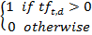
Figure 2.2 Weighting scheme for Boolean frequency

Figure 2. 2 shows the weighting scheme for Boolean frequency. The weighting scheme shows that the weighting scheme for a certain term is 1 if the term (t) occurs in the document (d), and 0 if it doesn’t occur in the document.

        - Raw frequency
Raw frequency is done by assigning to each term a weight that depends on the number of occurrences of a certain term (t) in a document (d).

Figure 2.3 Weighting scheme for raw frequency

Latent Dirichlet Allocation
Latent Dirichlet Allocation (LDA) is a generative probabilistic model of a corpus, where documents are represented as random mixtures on latent topics and each topic is characterized by a words distribution (Blei, Ng, & Jordan, 2003, p. 996). LDA includes a process for generating the topics in each document, thus greatly reducing the number of parameters to be learned and providing a clearly defined probability for arbitrary documents.
LDA is represented as a hypothetical generative process for a corpus. The steps in the LDA are as follows (Aggarwal & Zhai, 2012, p. 142-143).
- Choose the term probabilities for each topic.
- Choose the topics for each document.
- Choose the topic for each token.
- Choose each token.

Natural Language Processing Tools

Twokenizer
Tokenization in the social media domain, especially Twitter is challenging due to the lack of orthographic conventions, such as punctuation, emoticons, URLs, and other symbols. To overcome these difficulties, Twokenizer was made. Twokenizer is a rule-based tokenizer, emoticon, and URL detector that treats hashtags, @-replies, abbreviations, strings and punctuation, emoticons and Unicode glyphs as tokens (O’Connor, Krieger, & Ahn, 2010, p. 385). This twitter tokenizer was rewritten and revised by adding a grammar of horizontal emoticons known as “Eastern-style”, also adding a number of other improvements to the patterns and recognition patterns for URL by using a list of top-level and country domains (Owoputi et al., 2013, p. 384).

Gensim
Gensim is a library to parse, process, and transform corpora into vector space (Rehurek & Sojka, 2010, p. 49). The library also provides implementation of popular information retrieval algorithms such as Latent Dirichlet Allocation and Latent Semantic Analysis.

Machine Learning

Definition of Machine Learning
Machine learning is defined as a set of methods to recognize patterns from a given dataset, in which these learned patterns will then be used to perform predictions on future given datasets (Murphy, 2012, p. 1). It gives a machine the ability to learn from examples, without being programmed explicitly. Machine learning is associated with natural language processing, as it enables the system to process and learn from the large amount of data automatically, instead of making rules one-by-one which is costly and prone to human error.
The field of machine learning is wide, as there are different kinds of problems and approaches to be taken into consideration. There are different types of machine learning, depending on a system’s nature of learning, or the output of a machine learning system.

Machine Learning Categories Based on Learning Nature
Machine learning is divided into several categories based on how it performs the learning process. The categories are as follows.
- Supervised learning
In supervised learning, the system is given a dataset containing a collection of known inputs and outputs to a certain problem, in which the system will explore and learn this given dataset to predict outputs to unseen inputs (Mohri, Rostamizadeh, & Talwalkar, 2012, p. 7). Supervised learning is commonly implemented into classification and regression tasks. The goal of a classification task is to map inputs to a predefined set of discrete classes as outputs (Murphy, 2012, p. 3). While the objective of a regression task is similar to classification, regression outputs a continuous value (Murphy, 2012, p. 8).
This study will implement a supervised learning approach to classify Twitter users according to their personality traits.
- Unsupervised learning
Unlike supervised learning, in unsupervised learning, a system is given a non-labeled dataset (without inputs and outputs), and the system is required to discover structures and patterns in the given dataset (Murphy, 2012, p. 9). Examples of unsupervised learning tasks include clustering and dimensionality reduction. Clustering is the task of dividing instances (training samples from the dataset) into different groups based on the resemblance and similarity of the instances (Witten, Frank, & Hall, 2011, p. 41).
- Reinforcement learning
In reinforcement learning, the training and testing stages are intermixed. The system learns by interacting with its environment, which will occasionally result in the system earning a reward. The system continues to explore the environment until it maximizes its reward (Mohri et al., 2012, p. 8).
- Semi-supervised learning
A semi-supervised learner is given a dataset where some examples have been labeled, and some others not labeled (Mohri et al., 2012, p.7). There are different kinds of assumptions that have to be made to make use of unlabeled data (Chapelle, Schölkopf, & Zien, 2006, p. 4). A semi-supervised learning approach provides great advantage for cases where there is a considerable amount of unlabeled data available, but is costly to obtain labeled dataset.

Machine Learning Algorithm
There are many machine learning algorithms that have been developed throughout the ages. These algorithms work according to their learning nature. Due to the abundant amount of machine learning algorithms which are beyond the scope of this study, this section will focus on only two machine learning algorithms which will be used in the current study, namely Support Vector Machine and Gradient Boosting Tree.

Support Vector Machine
Support vector machine is a binary classification supervised learning algorithm which makes use of feature space and linear decision surfaces (Cortes & Vapnik, 1995, p. 274). The instances from two different classes are mapped into a feature space. Three linear decision surfaces are constructed based on the positions of the instances. These linear decision surfaces consist of two margins and one optimal hyperplane. The goal of the support vector machine learning algorithm is to find the function of a hyperplane where the distance of the two margins is at the maximum.
Despite being a linear classifier, support vector machines have the advantage to perform non-linear classification tasks by applying kernel tricks, which allows the instances to be mapped to a higher-dimensional feature space (Auria & Moro, 2008, p. 6). Another advantage of the support vector machine algorithm is that this algorithm is designed to be robust. The intuition of finding the maximum distance between these two margins is what makes this algorithm robust, thus minimizing the risk of overfitting (Murphy, 2012).

Sequential Minimal Optimization
Utilizing a support vector machine algorithm requires solving a large quadratic programming optimization problem. The Sequential Minimization Optimization algorithm quickly solves Support Vector Machine’s quadratic programming problem (Platt, 1998, p. 1). The optimization requires smaller memory utilization and smaller computation time.

Gradient Boosting Tree
Gradient boosting tree is a type of boosting machine learning algorithm which produces an ensemble of weak prediction models, with trees as the base learner of the algorithm.

XGBoost
XGBoost is a gradient boosting tree library, which is proven to achieve state-of-the-art results on many machine learning challenges (Chen & Guestrin, 2016, p. 785). The XGBoost is based on the fundamentals of a gradient boosting tree algorithm, and is designed to be highly efficient, flexible, and portable. XGBoost has implemented important system and algorithmic optimizations which enables it to run more than ten times faster than existing machine learning solutions. It is also able to scale to billions of examples in distributed or memory-limited settings.
A gradient boosting tree algorithm produces a model with a weak learner by means of boosting. In boosting, weights are applied to each instance. The concept of boosting is to give more weights to previously misclassified instance, so that the classifier will learn from its misclassification (Murphy, 2012, p. 554).
Several recent research has been conducted with XGBoost, and results report that said library gives better classification accuracy compared to other machine learning algorithm.
Ayumi (2016, p. 4) conducted a study to investigate action recognition using several algorithms. The results show that XGBoost produces accuracy ranging from 96.68% to 99.82%. The difference in accuracy ranges from 53.40% to 98.87% for Support Vector Machine, and Naive Bayes ranging from 37.92% to 48.8%.
Another literature by Babajide Mustapha & Saeed (2016, p. 9) conducted a study to predict biological activity based on activity of compound molecular structure. Results show that XGBoost was able to outperform other algorithms like Random Forest, Support Vector Machine, Radial Basis Function Neural Network, and Naive Bayes, ranging from an accuracy of 94.47% to 98.49% accuracy.
In another study on forecasting stock market price by Dey, Kumar, Saha, & Basak (n.d., p. 8), XGBoost was also tested along with other algorithms. The result reported that SVM performs well with a nearly 80% accuracy, but XGBoost performed better (more than 88%).

Machine Learning Tools

WEKA
Waikato Environment for Knowledge Analysis (WEKA) is a data mining software which has a collection of machine learning algorithms. The motivation for creating the program came from a perceived need for a standard workbench to easily access machine learning techniques. The system is widely used for research in data mining among widespread audience such as academia or business cirles. (Hall et al., 2008, p. 10).
WEKA’s collection of machine learning algorithms and preprocessing tools allows users to try out machine learning methods on datasets. The system is open source, which allows users to develop the program further. The program’s functions are also callable via Java code. (Witten et al., 2011, p. 405).
WEKA offers a graphical user interface called The GUI Chooser which provides users to supporting user interfaces, system information, logging information, and the main applications in WEKA.

R
R is a system for statistical computation influenced by S language (Ihaka & Gentleman, 1996, p. 300). R consists of language and run-time environment with graphics, a debugger, access to certain system functions and the ability to run programs stored in R script file (Rizzo, 2007, p. 3).

Android

Overview of Android
Android is an open source operating system by Google based on the Linux kernel, and runs on mobile devices (MohdAnis & Subramaniam, 2014, p. 2319). It is owned by the Open Handset Alliance association, which aims to accelerate innovation in mobile and offer consumers a richer, less expensive, and better mobile experience.
Android’s open source nature invites interests from developers to build their applications on Android. To ease accessibility to these applications, Android provides a digital distribution service named Google Play. As a result, Android has many applications from various kinds of categories, totaling up to approximately 2 million applications published on the Google Play service (Statista, 2016b). As an open source platform, Android allows developers to fully study and understand the operating system in order for them to implement their desired features into their application. Since Android is based on the Linux kernel architecture, it also offers the same advantage as the Linux desktop system, namely it doesn’t require drivers to be rewritten. The kernel also provides several functions (Farkade & Kaware, 2015, p. 41), which are as follows.
- Enforcement of application permissions and security.
- Low-level memory management
- Process management and threading
- The network stack
- Display, keypad input, camera, WiFi, flash memory, audio, and IPC driver access

Android Studio
Android Studio is an official Integrated Development Environment (IDE) for the Android platform. The development of the IDE was a collaboration between Google and JetBrains. Before Android Studio was released, the Android Developer Tools (ADT) is used for Android application development, and is built on Eclipse. As an official IDE for the Android platform, Android Studio eases the development process and makes access to Android development simpler (Craig & Gerber, 2015).

Java

Overview of Java Programming
The Java programming language is an object-oriented programming language (Flanagan, 2005, p. 1). It is the language used to create Java applications, applets, and servlets. The program is then compiled into machine language with Java Virtual Machine.
Java has 5 main benefits:
            - Write Once, Run Anywhere
Writing a Java application means writing the application for a Java platform. Java support is integrated into almost all major operating systems, which enables the application to run almost anywhere.
            - Security
The language and platform were designed with security in mind. Java platform allows users to download untrusted code over a network and run it in a secure environment.
            - Network-Centric Programming
Java allows ease to work with resources across the network. It also allows ease to create network-based applications using client/server or multitier architectures.
            - Dynamic, Extensible Programs
Java uses modular classes which are only loaded when needed. An application can decide which class it needs and loads them when it needs said class. It is also able to extend itself by loading the classes it needs to expand its functionality.
            - Internationalization
Java uses 16-bit Unicode characters from universal phonetic alphabets and ideographic character sets, which makes it easy to write internationalized programs with Java than with other environment.
            - Performance
Java code are compiled to portable byte-code format by the Java Virtual Machine. This architecture allows Java to compile.
            - Programmer Efficiency and Time-to-Market
Java is a well-designed programming language, which allows programmers to get results quickly from what they code. Better code reduces the development time that programmers have to spend creating the program.

Netbeans
Netbeans is a Java Integrated Development Environment (IDE) which enables fast application development (Heffelfinger, 2015, p.7). It is free and open-source and widely used to develop programs in Java, PHP, C/C++, HTML, and JavaScript.

Web Service
A web service is a web application which is delivered over HTTP (Kalin, 2009, p. 1). The web application is hosted on a server, and can be accessed through a device with a URL. Applications with web services can run on any platform, because of its platform independent characteristic (Guruge, 2004, p. 49). It can also be developed with any programming language.

Tomcat
Apache Tomcat is an open-source Java servlet container which is used to run Java applications on the web (Khare, 2012, p. 7). It implements Java EE specifications such as Java Servlets and Java Server Pages. It allows Java code to run on the web through a Java HTTP web server environment. The specifications are used for developing and deploying web applications and web services. It was originally developed for the Jakarta Apache project, but was expanded due to popular demand. Tomcat is available for free under the Apache License 2.0 license.

JExcel
JExcel is an open-source Java library which is integrated into any web and standalone applications and allows the reading, writing, and modification of an Excel file (Tragura, 2016, p. 147). JExcel is able to read file formats in Excel 95, 97, 2000, XP, and 2003 workbooks and generate spreadsheets in Excel 2000 format.

Joda-Time
Joda-Time is a Java date-time framework (Sharan, 2014, p. 412). The library was made due to Java’s difficult representation of time concepts. Stephen Colebourne began developing Joda-Time as a more flexible alternative to working with dates and time in Java (Spell, 2015, p. 93).

Commons Lang
Commons Lang is a collection of the utility classes that consist of the java.lang.packages. It provides various helper classes for said packages API, including string manipulation method, basic numerical methods, object reflection, creation and serialization, and system properties (Walnes, Abrahamian, Cannon-Brookes, & Lightbody, 2003, p. 205).

GSON
GSON is an open-source application programming interface written in Java that is used to convert Java object to JSON and vice versa (Komatineni & MacLean, 2013, p. 83). GSON parses JSON object by deserializing JSON object into Java object.

Related Works
This section provides an overview on natural language processing on social media. There are a total of 3 sections: an overview on examples of natural language processing on social media, examples of personality prediction on various social media platforms, and in-depth review on closely related personality prediction tasks.

Natural Language Processing in Social Media
In recent years, social media has attracted billions of users and have revolutionized the way we communicate with individuals, groups, and communities. Social media contains huge volume of publicly available data that can be processed to become useful information which also could benefit different areas such as industry, media, healthcare, politics, public safety, and security. The popularity of social media used by numerous people results in the abundant amount of content contained in the form of natural language via text posts as one kind of interaction in the platforms. This would give substantial opportunity for natural language processing (NLP) research on natural language contained in social media.
NLP for social media text requires adapting to the traditional NLP methods for tasks in the context of social media. This is one of the challenges social media language poses for NLP. Social media texts often contain free-form or informal nature that involves spelling inconsistencies, the free-form adoption of new terms, new type of language, abbreviation, and regular violations of grammar norms. Social media data challenges the traditional assumption of NLP research on the nature of the target text and the requirements for real-time responsiveness. However, there are various non-textual data sources that has rich context which can be used to enhance the robustness and accuracy of NLP models, providing valuable assistance in disambiguating content. New opportunities for social media analysis will be enabled when mature and robust NLP technologies tailored to social media data (Baldwin, 2012, p. 59).
Semantic analysis of social media has given rise to the emerging discipline of social media analytics which draws from NLP and other fields (Melville et al., 2009, p. 1). This helps develop automated tools and algorithms to monitor, capture, and analyze the enormous amount of data collected in order to predict user behavior (Farzindar & Inkpen, 2015, p. 101). The framework for semantic analysis in social media can be divided into three steps, that are: (1) Collecting data from social networks where the data can be in the form of stored textual information, dynamic online data collection processed in real time, or retrospective data collection for particular needs. (2) After that, the SASM pipeline is done, where the social media data transform into meaningful and understandable messages through social media information. Then, social media information is analyzed in order to produce social media intelligence. (3) The last step is that social media intelligence can be shared with users or presented to decision-makers to improve awareness, communication, planning, or problem solving.

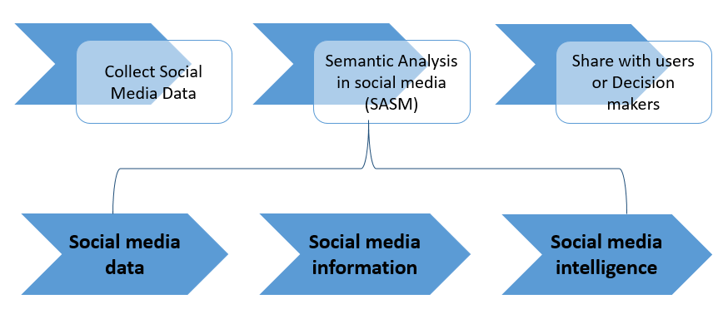
Figure 2.4 Framework for semantic analysis in social media
(Melville et al., 2009).

Some research using NLP in social media has been conducted in many specific fields. Named entity recognition (NER) is one of the NLP study that is being conducted by some researchers. An existing study on NER addresses the issue of standard NLP tool performance that is severely degraded on tweets by re-building the NLP pipeline beginning through chunking, with part-of speech (POS) tagging to named entity recognition (Ritter et al., 2011, p. 1524). They have demonstrated that those existing NLP tools perform quite poorly when applied to tweets. To address this challenge, they have annotated tweets and built tools trained on unlabeled, in-domain and out-of-domain data, showing substantial improvement over the state-of-the art. Another research presented a novel 2-step unsupervised NER system called TwiNER for targeted Twitter stream (Li et al., 2012, p. 721). Experimental result show promising result of TwiNER and also able to achieve comparable performance with the state-of-the-art NER system in real life targeted tweet streams.
Another specific field for NLP in social media is automatic summarization. A related study proposed the use of continuous vector representations for semantically aware representations of sentences as a basis for measuring similarity (Kågebäck et al., 2014, p. 31-39). They present two different methods for deriving phrase embedding, which will be used to compute sentence to sentence similarities. Another study showed that the effects of using phrase embedding for summarization was investigated and showed that these can significantly improve the performance of the state-of the-art summarization method (Lin & Bilmes, 2011). Further research regarding automatic summarization was done by producing a summary about what is currently happening from Indonesian hashtag on Twitter (Hariardi et al., 2016, p. 575-579). The methodology used to do the automatic summarization in this research are TF-IDF (term frequency-inverse document frequency) and Phrase Reinforcement Algorithm and using 2 sentences as the final summary result. Evaluation of the result is conducted by analyzing result using Precision and ROUGE measures. The summarization algorithm that being tested shows the quality of summary result is quite low where the average values of precision is 0.327 and ROGUE-1 is 0.3087. This happen because most of the data still contains a lot of noise.

Personality Prediction on Social Media
Personality prediction is a task where information about an individual’s personality trait is identified, given a set of data. There have been several approaches on automated personality prediction based on different kinds of dataset, such as essays, social media posts, videos, and social media behavior. This section will only focus on studies of personality prediction from text based on social media posts. There are several tools and corpora which are widely used in personality prediction studies, including the ones mentioned in this section. The first tool is called LIWC (Linguistic Inquiry Word Count), which is a text analysis tool used to evaluate psychological properties from language. The LIWC tool supports several languages such as Arabic, Chinese, Dutch, English, German, Italian, Korean, Norwegian, Portuguese, and Spanish. Approaches using the LIWC tool are often referred to as closed-vocabulary approaches or category based analysis. Some other tools used in the closed-vocabulary approach are MRC, NRC, SentiStrength and SPLICE. The second, while not exactly a tool, which is commonly used in the personality prediction task is the MyPersonality corpus. It contains records about psychometric scores and social media posts from Facebook users. There are also other related corpora available for other social medias, such as Personalitwit from Twitter (Celli, 2011, p. 1-5), and YouTube dataset (Biel & Gatica-Perez, 2013, p. 41-55).

Early Research (Blog)
One of the earliest research regarding personality traits and social media text was done on Blogger (Yarkoni, 2010, p. 363-373). The objective of this study was to find the correlations between personality traits and social media text. The dataset used contained 694 blogs from Google’s Blogger service. The personality model used in this study are The Big Five and NEO-PI-R. Yarkoni used both closed and open vocabulary approaches for the personality prediction model. 66 LIWC categories were used for the closed vocabulary approach, while the open vocabulary consisted of dividing the text into individual words. His results showed that Openness correlated with 393 words, whereas the other traits correlated with fewer than 30 words. Lower order facets from the NEO-PI-R models were also found to correlate with categories from the LIWC tool.

Twitter Dataset
Another research was attempted to identify personality traits of Twitter users based on The Big Five model (Golbeck, Robles, Edmondson, & Turner, 2011, p. 149-156). The features used in their personality prediction model are a set of Twitter statistics (data that is already available from each Twitter user, such as number of followers, following, mentions, etc.) and language features. They utilized 79 text features from LIWC and 14 text features from MRC. Sentiment analysis was also done word by word to each user’s tweets. The data is then run in Weka using Gaussian Process and ZeroR. Evaluation was done by calculating the Mean Absolute Error (MAE) for each personality trait. They managed to obtain the smallest MAE with a value of 0.11923333 for the Openness trait by using the ZeroR algorithm.
A similar task was conducted to find correlations between The Big Five personality traits and topics, posting platforms, and the tendency of a user to retweet (Celli, 2011, p. 2). Unlike Golbeck’s research, Celli only made use of 12 cross-linguistic features based on a previous research (Mairesse, Walker, Mehl, & Moore, 2007).
Another research was conducted by using the Dark Triad personality model with 2,927 Twitter users (Sumner et al., 2012, p. 388). 337 features were selected for the personality prediction task, consisting of Twitter statistic data and frequency of pre-defined words for each individual. The prediction task was then run with 4 algorithms from WEKA: Support Vector Machine, Random Forest, J48, and Naïve Bayes.
Personality prediction has also been conducted in a semi-supervised way, with Brazilian TV shows as an additional label (Lima & de Castro, 2013, p. 195-203). In their study, they used a list of meta-attribute features, which was then run using a Naïve Bayes classifier with a supervised and semi-supervised learning approach. Results showed that the semi-supervised learning outperforms supervised learning, with 0.8415 as their highest accuracy.

Blogger Dataset
Further research on personality prediction via social media was attempted on Blogger (Iacobelli, Gill, Nowson, & Oberlander, 2011, 568-577). This study also utilizes texts from bloggers, but further improves Yarkoni’s study by doing a personality prediction task based on the selected features. In addition, he also did a comparison of performances achieved between different approaches of the personality model. The different approaches used are: (a) different n-grams (n=1 or n=2), (b) utilization of stop words (using stop words or omitting stop words), and (c) term weighting (Boolean weighting or TF-IDF weighting. These approaches were also compared to the performance when using the LIWC tool. These features were then classified in Weka using Support Vector Machine (SVM). The experiment’s results showed that the best accuracy, with a value of 84.36%, was achieved by using bigrams (n=2), utilizing stop words and implementing Boolean weighting. This proves that the open vocabulary approach (by extracting n-gram tokens) can be used to predict personality, since it outperforms the closed vocabulary approach (using LIWC). However, they also mention that the classification may have overfitted, due to the few amount of bigrams in each personality trait.

Facebook Dataset
Personality prediction was also attempted on Facebook. One of these studies utilized a Facebook dataset named MyPersonality corpus (Schwartz et al., 2013, p. 1-16). This study attempted to perform the personality prediction task using an open-vocabulary approach. Significant features were found between n-grams (n=1 to 3), extracted topics with Latent Dirichlet Allocation and personalities. The models created with these features outperformed the model created based on LIWC.
Another open vocabulary approach on The Five Factor Model personality prediction using the MyPersonality dataset was conducted using Support Vector Regression and Latent Dirichlet Allocation models (Liu, Wang, & Jiang, 2016, 155-163). Their results show that the LDA models, sLDA (supervised Latent Dirchlet Allocation) and PT-LDA (Probabilistic Topic model-Latent Dirichlet Allocation) outperforms the Support Vector Regression model (topics and N-grams). Furthermore, they also proved that PT-LDA is more robust and improves computational efficiency up to 64%.
Meanwhile, another attempt at closed-vocabulary approach was done by using the LIWC tool (Farnadi, Zoghbi, Moens, & De Cock, 2013, 14-18). This study used 81 LIWC features, 7 social network features, 6 time-related features, and 6 other features that can be extracted from the posts’ content. The learning algorithms tested on this study are Support Vector Machine, K-Nearest Neighbor, and Naïve Bayes. The highest precision achieved by combining all these features using K-Nearest Neighbor is 0.54, while highest precision was obtained by merely using social network features, reaching a precision of 0.71.

Youtube Dataset
This task was also implemented on YouTube personality datasets (Farnadi et al., 2014, p. 1-6). The dataset consisted of audio-video features, speech transcripts, gender, and personality impression scores from a total of 404 YouTube vloggers. 7 types of features were used in this study: gender, 25 audio-video features, 81 LIWC features, 10 NRC features, 14 MRC features, 3 SentiStrength scores, and 74 SPLICE features. Different kinds of multivariate regression algorithms with mostly decision trees as the base learner were applied to compare their performances. The system achieved the lowest root-mean square error (RMSE) in predicting the Conscientiousness trait, with a value of 0.64, using Multi-Target Stacking Corrected and Multi-objective random forest multivariate regression algorithms.

Non-English Dataset
The previously mentioned researches are conducted with social media datasets in English. Recent studies have attempted to predict personality based on non-English datasets. One of these studies was conducted with a dataset which consists of English, Spanish, Dutch, and Italian tweets (Arroju et al., 2015, p. 1-10). Tokenized terms are matched with an enhanced LIWC tool. Afterwards, the personality prediction task is executed with a multivariate regression technique called Ensemble of Regressor Chains Corrected (ERCC). They were able to achieve best results in predicting the Openness trait for English and Spanish languages, with an MAE value of 0.0811.
Another attempt was done for Twitter texts in Indonesian language. An attempt in personality prediction on Twitter text using the Indonesian language was done by translating the MyPersonality dataset contents into said language (Pratama & Sarno, 2015, 170-174). Similar to other open-vocabulary approaches, they extracted the top 750 words that frequently appear in the dataset, and compared the Naïve Bayes, K-Nearest Neighbors, and Support Vector Machine algorithms for the classification process. While they obtained 72.29% as their highest accuracy, they noted that a native Indonesian language dataset may be more reliable for classification.
A Chinese dataset consisting of 222 Taiwan Facebook users was also utilized for the personality prediction task, by using an open-vocabulary approach (Peng, Liou, Chang, & Lee, 2015, p. 9-14). They conducted the prediction task with different methods to compare their performances: (a) weighting scheme (term frequency (TF) or term frequency-inverse document frequency (TF-IDF)), (b) tokenization tool (Jieba segmentation tool or scikit-learn tokenizer), and (c) feature selection algorithm (chi-squared test or recursive feature elimination). A 73.5% value was achieved as their highest accuracy by using the Jieba Chinese text segmentation as their tokenizer, using the TF weighting scheme, chi-squared test as the feature selection algorithm, and SVM as the machine learning algorithm. One thing worth noting from this study is that the Jieba tokenizer improves precision up to 60% in the case of utilizing a Chinese dataset.
An experiment using a different Chinese dataset from Sina Weibo was also used to predict personality (Wan, Zhang, Wu, & An, 2014). They used 2 tools to execute the task: LIWC2007 Chinese Simplified Dictionary and IKanalyzer, a Chinese word segmentation tool. There are a total of 4 user behavior features, 3 interaction behavior features, and 71 text features which were used in this system. The Logistic Regression and Naïve Bayes were chosen as the machine learning algorithms for this study, with Logistic Regression yielding the highest precision in identifying the Agreeableness trait, with a value of 75.2%.

Cross-Media Dataset
There have also been attempts to predict personality by utilizing datasets from more than one social media. One of those attempts was done by combining features from Twitter and Instagram (Skowron, Tkalčič, Ferwerda, & Schedl, 2016). They extracted linguistic and Twitter statistics data from Twitter, while image and linguistic features were extracted from Instagram. These features were matched with different combinations, but the best result was achieved by using both linguistic and Twitter statistics data from Twitter, and image and linguistic features from Instagram, yielding an average root-mean square error of 0.66 for all personality traits.
Another cross-media personality prediction attempt was conducted by utilizing datasets from Facebook, Twitter, and YouTube (Farnadi et al., 2016, p. 109-142). They extracted LIWC, NRC, MRC, SentiStrength, SPLICE, demographics, and audio-video features for the YouTube dataset. The same features, except NRC and audio-video features, were applied to both the Facebook and Twitter dataset. The learning algorithm applied to the classification task were univariate and multivariate techniques with a decision tree or SVM algorithm as the base learners, although results showed that there wasn’t significant difference between univariate and multivariate techniques. They achieved the best result with techniques that applied the decision tree algorithms. Even though they managed to perform cross-media personality prediction, they noted that expanding their model with training samples from different sources didn’t improve the learning performance.

Table 2.1 Dataset Size Used in Different Social Medias
Social Media |  | Minimum | Maximum
Blogger |  | 694 users | 3000 users
Facebook |  | 222 users | 74941 users
Sina Weibo |  | 131 users | 818 users
Twitter |  | 50 users | 2927 users
YouTube | 404 users
Renren | 80 users
Dataset sizes used in different social medias which are mentioned in this section.

The task of cross-media personality prediction was further improved by applying Heterogeneity Entropy Neural Network (HENN) to extract features from Renren and Sina (Xianyu, Xu, Wu, & Cai, 2016, 1-6). The HENN learning algorithm was used to overcome the semantic and heterogeneity gap caused by cross-media platforms. The CCA-based and Corr-AE learning methods were also applied to compare their performances with the HENN method. Results showed that HENN successfully outperformed other learning methods with 0.0723 as their smallest MAE value in predicting the Openness trait.
A summary of the mentioned personality prediction attempts in this paper is provided in Table 2.1 and Table 2.2.
Table 2.1 consists of the range of dataset size used in various social media which are mentioned in this paper. The dataset size in Table 2.1 is based on the number of users contained in the dataset. Celli (2011) and Lima & de Castro (2013) are excluded from this table as its dataset size are based on the number of tweets. Table 2.2 is a list of studies with information about which social media is personality prediction performed on, the authors of the study, the features used in the study, and the best results that are achieved by the study.
Table 2.2 Summary of personality prediction attempts mentioned in this section.
Dataset | Author(s) | Features |  | Best Results
Twitter | Golbeck, Robles, Edmondson & Turner | LIWC and MRC text features |  | MAE | 0.11923333
Twitter | Sumner, Byers, Boochever, & Park | Twitter statistics and pre-defined words frequency |  | Accuracy | 0.919
Twitter | Lima & de Castro | Meta-attributes, watched TV shows |  | Accuracy | 0.8767
Twitter | Arroju, Hassan, & Farnadi | LIWC (enhanced) |  | MAE | 0.0811
Blogger | Iacobelli, Gill, Nowson, & Oberlander | n-grams |  | Accuracy | 0.8436
Facebook | Schwartz et al. | n-grams, extracted topics |  | R (square root of coefficient determination) | 0.42
Facebook | Liu, Wang, & Jiang | latent topics |  | RMSE | 0.479*
Facebook | Farnadi, Zoghbi, Moens, & De Cock | LIWC, social network feature, time-related feature, content feature from posts |  | Precision | 0.54**
Facebook | Pratama & Sarno | n-grams |  | Accuracy | 0.7229
Facebook | Peng, Liou, Chang, & Lee | n-grams |  | Accuracy | 0.75
Table 2.2 Summary of personality prediction attempts mentioned in this section.
Dataset | Author(s) | Features | Best Results

YouTube | Farnadi et al. | audio-video features, speech transcripts, gender, personality impression |  | RMSE | 0.64
Sina Weibo | Wan, Zhang, Wu, & An | LIWC, user behavior, interaction behavior |  | Precision | 0.752
Sina Weibo | Xianyu, Xu, Wu, & Cai | Bag-of-textual words |  | MAE | 0.0723
Instagram + Twitter | Skowron, Tkalčič, Ferwerda, & Schedl | Linguistic (Twitter, Instagram) | LIWC, ANEW, Dialog Act, Sentiment | RMSE | 0.66
Instagram + Twitter | Skowron, Tkalčič, Ferwerda, & Schedl | Image (Instagram) | PAD, brightness, saturation, hue-related, content-based features | RMSE | 0.66

Table 2.2 Summary of personality prediction attempts mentioned in this section.
Dataset | Author(s) | Features | Best Results

Facebook + Twitter + YouTube | Farnadi et al. | Facebook | LIWC, MRC, SentiStrength, SPLICE, demographics, user behavior | RMSE | 0.115
Facebook + Twitter + YouTube | Farnadi et al. | Twitter | LIWC, MRC, SentiStrength, SPLICE, age, gender | RMSE | 0.115
Facebook + Twitter + YouTube | Farnadi et al. | YouTube | LIWC, NRC, MRC, SentiStrength, SPLICE, audio-video features, gender | RMSE | 0.115
*result from SLA, but isn’t as robust as PT-LDA
**best result is 0.71, but doesn’t involve any linguistic featur

In-Depth Review on Closely Related Works
This section provides an in-depth coverage of previous studies which are closely related to the current study. The title and details of the related works are as follows.

Mining User Personality in Twitter
This study was conducted by Celli (2011, p. 1-5). This study utilized a language recognition tool which was pre-built from a previous study (Celli, 2009a, 2009b), and a personality extraction tool to annotate a dataset from Twitter, which they refer to as “Personalitwit”.
This research used 25700 posts from Twitter as a corpus. The personality traits that are considered for this study are Extraversion, Emotional Stability, Agreeableness, Conscientiousness, and Openness.
The study selected 12 cross linguistic features in order to develop the recognition tool, namely all punctuations, comma, reference to other user, exclamation mark, negative emoticons, numbers, parenthesis, positive emoticons, question mark, long word, type/token ratio, and word count. The personality model itself are represented in strings of five characters that stand for the traits of the “Big Five” and take 3 possible values: y, n, and o, where y represents high level of certain personality trait, n referring to low level of certain personality trait, and o representing neutral personality trait.
The information provided in the annotation of the corpus includes the following.
- Username
- Post
- Date
- Platform from which the user posted
- Personality trait
- Accuracy of the personality trait
- Validity of the personality trait
- Language
Results showed a mean accuracy of 0.6651 and mean validity of 0.6994.

Table 2.3 Co-occurrence of topics, retweet and posting platforms with most frequent personality models
(Source: Celli, 2011, p. 4)
 | nynny | nynoy | nyony | nyooy | nyyoy | ooooo
Binladen | 0.0% | 37.5% | 12.5% | 50.0% | 0.0% | 0.0%
Royalwedding | 7.6% | 18.4% | 8.5% | 39.6% | 22.0% | 4.0%
Retweet | 17.5% | 15.5% | 21.4% | 29.3% | 16.1% | 0.2%
Tweet | 5.1% | 18.5% | 8.6% | 44.8% | 10.8% | 12.2%
Twitter | 6.8% | 17.0% | 10.8% | 38.3% | 13.0% | 14.0%
Blackberry | 9.3% | 9.4% | 18.6% | 29.1% | 15.6% | 18.1%
Iphone | 3.9% | 12.8% | 7.7% | 37.2% | 16.9% | 21.5%
Ubersocial | 16.2% | 13.0% | 21.2% | 27.2% | 16.1% | 6.4%
Facebook | 8.7% | 22.4% | 14.1% | 46.8% | 7.6% | 0.4%

From the table, the research concluded that in general the personality of people writing in Twitter is an introvert, secure, and open-minded person (nyooy). Analysis of the data showed that different writing styles and personality traits are associated to different communities using devices to post on Twitter.

Predicting Personality from Twitter
This research was done by Golbeck et al. (2011, p. 149 - 156). The core research question from this study asks whether social media profiles can predict personality traits.
They created a Twitter application administering a 45-question version of the Big Five personality inventory to users. Subjects would take the test and for each, collect the most recent 2,000 tweets from the user (or all tweets if they all had less than 2,000). This study also collects user statistics as features, such as:
- Number of replies
- Number of hashtags
- Number of links
- Words per tweet
- Number of followers (people following the user)
- Number of following (people the user follows)
- Density of social network
- Number of “@mentions”

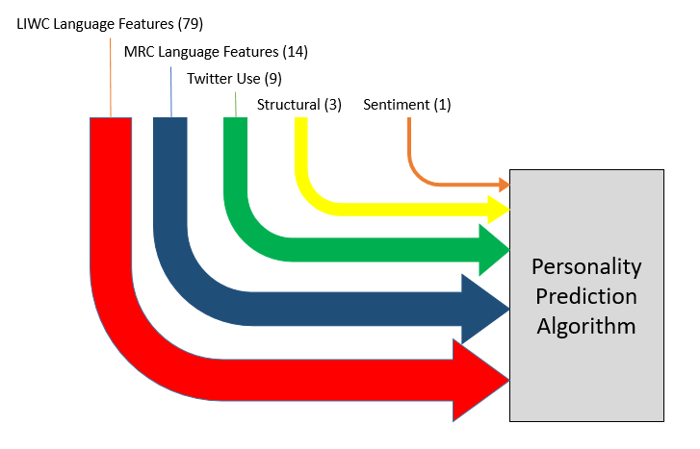
Figure 2.5 Features considered in the study.
(Source: Golbeck et al., 2011, p. 152)

Various features were selected to predict a user’s personality, namely LIWC language features, MRC language features, Twitter use (user activity on Twitter), structural features (number of friends and network density), and sentiment. LIWC produced 81 different features of text from 5 categories: “standard counts”, “psychological processes”, “relativity”, “personal concerns”, and “other dimensions”. “Standard counts” features such as word count, words per sentence, and swear words count could reflect the verbosity and tone of the user. The other 3 categories’ values were given as the percentage of words in the input that match words in a given category. This produced 79 text features.
After selecting LIWC language features, the dataset is run again in MRC Psycholinguistic Database, a list of over 150,000 words with linguistic and psycholinguistic features of each word and computed the average non-zero score for each feature over all the words from each user. The score for each user’s average sentiment was obtained using the General Inquirer dataset provides a hand annotated dictionary that assigns words sentiment values on a -1 to +1 scale. A Pearson correlation analysis is then run between the subjects’ personality scores and each of the features obtained from analyzing their tweets and public account data.
To predict the score of a given personality feature, this research performed a regression analysis in Weka and used two regression algorithms: Gaussian Process and ZeroR, each with a 10-fold cross-validation with 10 iterations.

Table 2.4 Mean Absolute Error on a normalized scale for each algorithm and personality trait
(Source: Golbeck et al., 2011, p. 155)
 | Agree | Consc | Extra | Neuro | Open
ZeroR | 0.129980265 | 0.146204953 | 0.1602416603 | 0.182122225 | 0.11923333
Gaussian Process | 1.130675423 | 0.14599073 | 0.160315335 | 0.18205923 | 0.11922558

The authors believe that a larger sample would have produced much better results. With only fifty subjects, building an effective training algorithm is difficult. However, the results they obtained even with a small sample shows promise that this technique can be useful for computing personality on Twitter and other micro-blogging sites.

Predicting Dark Triad Personality Traits from Twitter Usage and a Linguistic Analysis of Tweets
This study was conducted by Sumner et al. (2012, p. 386-393). Said study’s personality prediction task was done on Twitter. Similar to 2 of the previously mentioned studies, this study also used a closed-vocabulary approach. Unlike most personality prediction systems though, this study was built to predict the Dark Triad personality model and the Five Factor model.
The dark triad model consists of 3 personality traits, namely Narcissism, Machiavellianism, and Psychopathy. Narcissism defines a personality with a pattern of grandiosity, need for admiration, and lack of empathy. Machiavellianism is characterized as a personality with a tendency to deceive and manipulate other people for personal gain. Psychopathy is defined as a personality with lack of empathy and guilt, glib speech, pathological lying, a grandiose sense of self-worth, anti-social and promiscuous, and has a parasitic lifestyle.
A total of 2,927 Twitter users participated in this study. A Twitter application was developed to collect self-reported ratings with measures of Narcissism, Machiavellianism, Psychopathy, and measures of the Ten Item Personality Inventory (TIPI).
There are 4 types of features used in this study: friends, followers, number of tweets, and frequency of pre-defined words from each individual. A total of 337 features were selected for the prediction task. Each participant’s post content was analyzed using categories provided by the LIWC (Language Inquiry and Word count) 2007 tool.
There are 2 cut-off values used for classification: the median and the 90th percentile. The median value of a trait splits the sample in half, while the 90th percentile value represents 90% of the sample. The dataset was then labelled with high or low of each personality trait.
Classification was done using 4 algorithms from Weka, namely Support Vector Machine with sequential minimal optimization and polynomial kernel; Random Forest; J48; and Naïve Bayes. Additional 2 methods were used from a benchmark Kaggle model and winning Kaggle models.
Based on their results, they found out that narcissistic traits positively correlated with punctuations such as @ and # characters, where the @ character is used before other characters to imply mentions and replies to other users, while the # character is a hashtag which facilitates tweet searching. Narcissistic traits also positively correlated with words associated with sex.
Machiavellian traits were found to positively correlate with swear words, anger and negative emotions. Negative correlations were also detected for Machiavellian trait, which were positive emotions, and use of the word ‘we”.
Psychopathic traits positively correlated with swear words, anger, death, negative emotions, and filler words.
There are 7 evaluation methods used in this study: Area Under the Curve (AUC), geometric mean of true positive rate, geometric mean of true negative rate, arithmetic mean of true positive rate, arithmetic mean of true negative rate, accuracy for maximum geometric means, and accuracy for maximum arithmetic means. Indication of practical performance was calculated using the AUC. Results showed that psychopathic and extraversion traits were easier to detect than other traits, with psychopathic reaching an AUC of 0.641 and extraversion with an AUC of 0.644.
Table 2.5 shows the result obtained from this study’s personality prediction model.

Table 2.5 Evaluation metrics for median split against Dark Triad and Five-Factor Model personality traits
(Source: Sumner et al., 2012, p. 391).
Median Split
Trait | AUC | Acc Max A-Mean | Acc Max G-Mean | G-Mean | G-TPR | G-TNR | A-Mean | A-TPR | A-TNR
Psy | 0.641 | 0.610 | 0.610 | 0.611 | 0.642 | 0.582 | 0.610 | 0.641 | 0.583
Mac | 0.602 | 0.586 | 0.586 | 0.571 | 0.640 | 0.509 | 0.586 | 0.400 | 0.740
Nar | 0.612 | 0.598 | 0.598 | 0.577 | 0.589 | 0.565 | 0.598 | 0.370 | 0.789
Op | 0.591 | 0.582 | 0.582 | 0.564 | 0.556 | 0.573 | 0.582 | 0.318 | 0.820
Co | 0.605 | 0.593 | 0.593 | 0.588 | 0.671 | 0.516 | 0.593 | 0.683 | 0.506
Ex | 0.644 | 0.623 | 0.623 | 0.611 | 0.619 | 0.602 | 0.623 | 0.475 | 0.753
Ag | 0.600 | 0.587 | 0.587 | 0.566 | 0.545 | 0.588 | 0.587 | 0.368 | 0.775
Ne | 0.612 | 0.598 | 0.598 | 0.582 | 0.576 | 0.589 | 0.598 | 0.412 | 0.765

Table 2.6 Evaluation metrics for 90th percentile split against Dark Triad and Five-Factor Model personality traits
(Source: Sumner et al., 2012, p. 391)
90th Percentile Split
Trait | AUC | Acc Max A-Mean | Acc Max G-Mean | G-Mean | G-TPR | G-TNR | A-Mean | A-TPR | A-TNR
Psy | 0.678 | 0.896 | 0.660 | 0.651 | 0.640 | 0.663 | 0.863 | 0.024 | 1.000
Mac | 0.609 | 0.919 | 0.641 | 0.596 | 0.547 | 0.649 | 0.919 | 0.000 | 1.000
Nar | 0.625 | 0.890 | 0.683 | 0.596 | 0.504 | 0.705 | 0.890 | 0.023 | 0.999
Op | 0.603 | 0.877 | 0.600 | 0.587 | 0.571 | 0.604 | 0.877 | 0.020 | 1.000
Co | 0.611 | 0.858 | 0.541 | 0.594 | 0.681 | 0.518 | 0.858 | 0.000 | 1.000
Ex | 0.668 | 0.899 | 0.667 | 0.629 | 0.585 | 0.676 | 0.899 | 0.000 | 1.000
Ag | 0.647 | 0.876 | 0.696 | 0.618 | 0.531 | 0.720 | 0.876 | 0.000 | 1.000
Ne | 0.624 | 0.837 | 0.625 | 0.595 | 0.554 | 0.639 | 0.837 | 0.021 | 1.000

The authors stated that there are several limitations in their study.
The first limitation was due to a sample set which consists of followers of British celebrity Stephen Fry and Tony Hawk. But they compared their samples with other studies and found that their sample is generally consistent.
The second limitation is the use of LIWC. Language on Twitter is more likely written differently than those of correctly written speech. This means that some words may be manipulated into unrecognizable words to fit into the Twitter character limit, which is 140 characters.
The third limitation emerged in processing Twitter data using LIWC, which resulted in a relatively small number of features for machine learning. They mentioned that generating features from raw text may result in more features and better models.
Lastly, this study was based on self-assessment questionnaires, which could be easily manipulated to produce measurement error. However, this is a widely used method. This study also uses a large sample size, so masking by some participants wouldn’t cause a significant change in scores.

“The Big Five Traits” Personality Prediction System from Twitter Data (Sistem Prediksi Kepribadian “The Big Five Traits” Dari Data Twitter)
This study was conducted by Wijaya, Prasetia, Febrianto, & Suhartono (2016). The study attempted to create a personality prediction system based on user information on Twitter in English. The personality model used in this study is the Five Factor model.
A total of 4429 Twitter users were utilized as training data in this study, where each user is required to be actively tweeting in English. The mentioned study consists of 4 main steps: Twitter data extraction, feature extraction, WEKA processing, and system prediction.
- Twitter data extraction
Extraction of each Twitter user’s data is done through the Twitter API. The study extracted Twitter username, tweets of the user, number of user’s followers, number of accounts followed by the user, number of favorited tweets, number of mentions, and number of hashtags.
User tweets are preprocessed before utilizing it into the prediction system. The preprocessing steps taken are as follows.
- Removal of retweets
- Removal of emojis
- Removal of hyperlinks
- Feature Extraction
The features utilized in this study are LIWC and MRC. A total of 27 features are used in this study. The features are then divided into 3 levels: word level, message level, and Boolean.
Word level refers to the occurrence of a feature in a sentence.
Message level is the occurrence of the feature in the whole dataset. The Boolean feature only sets the occurrence value to 1 if the word exists in a post per user, and 0 if otherwise.

- WEKA Processing
This step involves using the WEKA software to perform some statistic calculations such as standard deviation (sd), average (mean), maximum value (max) and minimum value (min).
- System Prediction
The final step displays the prediction result to the application’s user interface

The classifier was built to identify combinations of the Five Factor model personality trait, which totals up to 32 classes. The personality prediction system was tested with the Support Vector Machine, ZeroR, and Naïve Bayes algorithm. Evaluation was done with 5, 10, 15, and 20-fold cross validation. A set of features were crossed with one another to evaluate which set of features would produce the best result.

Table 2.7 Accuracy of Personality Prediction system using K-Fold Cross Validation
(Source: Wijaya, Prasetia, Febrianto, & Suhartono, 2016)
K-fold Cross Validation | Accuracy
5 folds | 23.9557%
10 folds | 24.4751%
15 folds | 24.0912%
20 folds | 24.0912%

A comparison of accuracies obtained by the Support Vector Machine, Naïve Bayes, and ZeroR algorithm is presented in Table 2.8 below. The highest accuracy was achieved using the Support Vector Machine algorithm.

Table 2.8 Comparison of Accuracies by The Support Vector Machine, Naïve Bayes, and ZeroR algorithm
(Source: Wijaya et al., 2016)
Classifier | Accuracy
Support Vector Machine | 24.4751%
Naïve Bayes | 9.0765%
ZeroR | 21.0883%
Evaluation was also done by evaluating the prediction of each personality trait: Extraversion, Emotional Stability, Agreeableness, Conscientiousness, and Openness.

Table 2.9 Accuracy of Personality Prediction Evaluation
(Source: Wijaya et al., 2016)
Personality Trait | Accuracy
Extraversion | 61.5263%
Emotional Stability | 80.876%
Agreeableness | 64.1906%
Conscientiousness | 77.8597%
Openness | 70.49%

The authors compared the results from the current study to a previous study, and concluded that contextual features, when added to the set of features, improve the accuracy slightly.

Personality in 100,000 Words; A Large Scale Analysis of Personality and Word Use Among Blogger
This study is conducted by Yarkoni (2010). The study explores and analyzes personality and word use among 694 blogs.
The study uses a category-based and word-based approach to find the associations between language and personality.
The category-based analysis was done using 66 LIWC categories. On the other hand, the word-based analysis was done by separating blog text into word tokens.
The study found 145 significant LIWC feature correlations (p<0.5) using category-based analysis. Findings report that they discovered associations between language and personality. For example, they found that neuroticism correlated positively with categories like anxiety/fear, sadness, anger, and total negative emotions. Extraversion was associated with positive emotions and interpersonal interaction. Agreeableness had positive correlations with social communality and positive emotions and negatively correlated with negative emotion words and swear words.
In the word-based analysis, the author found that results reported with the word-level associations coverged with the category-level results. For example, the results for neuroticism in word-based analysis correlated positively with negative emotion words (e.g. “awful”, “depressing”, “lazy”, “terrible”, “stressful”). Extraversion correlated positively with social settings or experiences (e.g. “bar”, “restaurant”, “drinking”, “dancing”, “crowd”, “sang”). Openness had strong association with intellect and cultural experience related words (e.g. “poet”, “culture”, “narrative”, “art”, “universe”, “literature”).
The results from word-based analysis also identified unanticipated correlations. For example, correlations were found between Self-consciousness (a personality facet from Neuroticism) and the word “sizes”, Intellect (a personality facet from Openness) and “against”, Trust (a personality facet from Agreeableness) and “summer”, and Cooperation (a personality facet from Agreeableness) and “unusual”.
The study also found other associations which may have been masked by category-based analysis. The report shows that Agreeableness correlated positively with several words from the Sexual category (e.g. “loves”, “love”, “hug) but had negative correlations with others (e.g. “porn”, “gay”, “fuck”). This shows that while Agreeableness may have correlated positively with the sexual category of LIWC, it correlated positively only with words related to love and affection and not words related to sexual behavior.
Another result which reported associations masked by category-based analysis was a negative correlation between Intellect (a personality facet from Openness) and Space category. Reports show that the facet only positively correlated with words which don’t occur frequently and expressed relational spatial concepts (e.g. “among”, “between”, “further”, “under), but negatively correlated with words which expressed more concrete spatial terms (e.g. “out”, “top”, “bottom”, “down”).
The Excitement-Seeking personality facet from Extraversion also had masked associations. In the category-based analysis, there was no relation between School and said facet. The word-based analysis on the other hand, shows that Excitement-Seeking correlated positively with sports-related words within the School category (e.g. “football”, “team”, “basketball”, “coach”) but correlated negatively with words related to academic (“books”, “book”, and “desk”).

Large Scale Personality Classification of Bloggers
This study was done by Iacobelli et al. (2011, p. 568-577). The dataset chosen for this study are weblogs. The study focuses on an open-vocabulary approach, though a closed-vocabulary approach was also tested to compare the results. The chosen personality model to predict for this study is the Five-Factor personality model.
The weblog corpus was drawn from 3000 bloggers, processed as one file per author per month. HTML tags, embedded and quoted text were removed from each file. Each author was also asked to complete a self-assessment personality questionnaire measuring each Five-Factor model personality traits. The authors were then divided into high and low scoring for each personality trait. For classification purposes, the high-low groups for each trait were balanced, so that authors from larger set matched the number of authors from smaller set.
Preprocessing of dataset was done through 4 methods, which are as follows.
- Words were stemmed using Porter’s stemming algorithm.
- Proper names were replaced with token. Detection was performed by searching for continuous set of words with initial letters capitalized.
- Variants of laughter were replaced by common token.
- Words containing apostrophes were tagged.
Different datasets were built for each personality trait to test each variation’s performance. The variations are as follows.
- The word window sizes used were unigrams and bigrams.
- The inclusion of stop words (including stop words or omitting stop words).
- Using boolean or TF-IDF weighting scores.
A total of 8 datasets were produced as a result from combining features and weighting schemes. An additional dataset was created based on psychologically defined categories from the LIWC tool.
The dataset was applied to Weka’s subset selector to include only features that contribute the most to accurate classification. Classification of personality traits was done using the Support Vector Machine and LibLinear classifier in Weka. 10-fold cross validation was used to classify the datasets.
Results showed that greatest accuracy was achieved with boolean weighting, bigrams, and including stop words.

Table 2.10 Accuracy scores by trait and feature sets using SVM.
Feature sets were abbreviated as (b)ool or (f)requency scoring; 1 (unigram) or 2 (bigram) grams; include stop words (sw) or omit stop words (wo).
(Source: Iacobelli et al., 2011, p. 573)
Dataset | b-2-sw | b-1-sw | b-1-wo | b-2-wo | f-1-sw | f-1-wo | f-2-sw | f-2-wo | LIWC
N | 70.51 | 70.47 | 70.12 | 67.77 | 67.77 | 67.25 | 67.83 | 65.24 | 59.56
E | 71.68 | 67.80 | 68.40 | 63.99 | 64.84 | 65.22 | 69.42 | 64.15 | 54.86
O | 84.36 | 81.44 | 79.14 | 77.49 | 74.74 | 74.74 | 77.93 | 73.77 | 56.86
A | 78.31 | 69.98 | 69.49 | 71.09 | 66.01 | 64.78 | 72.61 | 68.07 | 61.09
C | 79.18 | 75.17 | 72.74 | 76.41 | 68.79 | 68.34 | 73.87 | 73.98 | 56.11

The authors stated that the classification may have overfitted the data due to the little amount of bigrams in each personality trait. However, given the size of the corpus, the features provide an insight on each personality trait’s choice of words.

Personality, Gender, and Age in The Language of Social Media: The Open-Vocabulary Approach
This study was conducted by Schwartz et al. (2013, p. 1-16). Said study utilized an open-vocabulary approach. This research aimed to demonstrate that more insight on gender, age, and personality types can be obtained through an open-vocabulary approach, and present the correlation between words and personality types with word cloud visualization.
The dataset used in this study was provided by the myPersonality corpus, which was a Facebook application that allowed Facebook users to take personality questionnaires. In return, the application records the user’s psychometric and profile data.
The myPersonality dataset was narrowed down to a total of 15.4 million status updates from 74,941 users with the following criteria:
- Users must indicate English as their primary language.
- Users must have written at least 1,000 words in their status updates.
- Users must be less than 65 years old.
- Users must have indicated their gender and age.
The study is divided into 3 main steps: linguistic feature extraction, correlational analysis, and visualization.
- Linguistic feature extraction
Linguistic feature extraction is the act of retrieving linguistic information from the user’s status update. It involves 2 types of linguistic features, which are words and phrases, and topics.
Words and phrases refer to sequences of 1 to 3 words. The status updates are tokenized with their self-built tokenizer, which has the ability to capture emoticons. In extracting phrases, only sequences of words with high informative value are considered. The informative value is calculated based on the phrase’s pointwise mutual information (PMI), which is the ratio of the joint probability to the independent probability of the phrase.

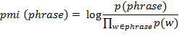
Figure 2.6 Pointwise Mutual Information
(Source: Schwartz et al., 2013, p. 5)

All word and phrase counts are normalized by each subject’s total word use using the following formula.

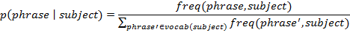
Figure 2.7 Normalized Phrase Counts and Word
(Source: Schwartz et al., 2013, p. 5)

After normalization, the value is applied with Anscombe transformation for variance stabilization.

Figure 2.8 Anscombe Transformation
(Source: Schwartz et al., 2013, p. 5)

The Anscombe transformed “relative frequencies” of words or phrases are used as the independent variables.
Finally, to keep the focus on the common language used, the extracted words and phrases are filtered to only accept words and phrases which are at least used by 1% of the user.
The second linguistic feature is topics. This feature consists of word clusters based on topics detected using Latent Dirichlet Allocation (LDA). The LDA model performs with the assumption that the words in the document contain a combination of topics. The LDA algorithm is implemented using the Mallet package.
To utilize topics as a feature, the probability of a user’s usage towards a certain topic is calculated using the following formula.

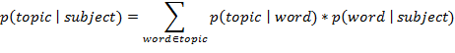
Figure 2.9 Probability of a Certain Topic’s usage
(Source: Schwartz et al., 2013, p 5)

- Correlational analysis
The correlational analysis produces a list of the most distinguishing language features for words, phrase, or topics. The features are considered significant if they are less than a Bonferroni-corrected two-tailed p of 0.001.
An example of a distinguishing feature found through the correlational analysis is that people in low elevations talk about ‘beach’ more, while people at high elevations talk about ‘mountains’ more.
- Visualization
Significant correlations from the previous step are visualized using word clouds. The word clouds are scaled based on their characteristics: scale word size according to strength of correlation of the word with the demographic or psychological measurement of interest and use color to indicate frequency over all subjects.
Figure 2.10 shows the word cloud for users with high extraversion, introversion, emotional stability, and neuroticism from said study.

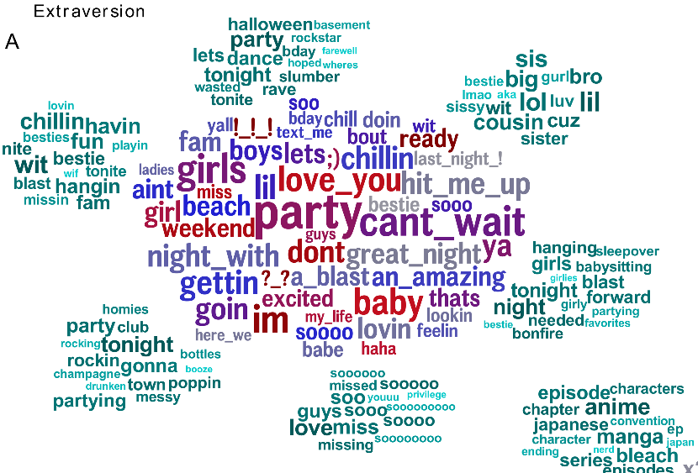
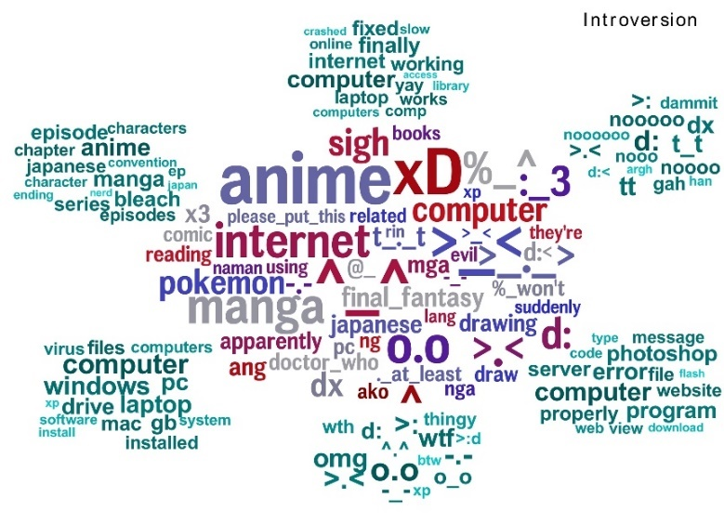
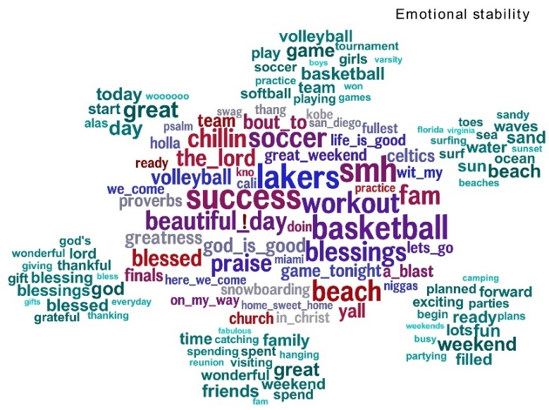
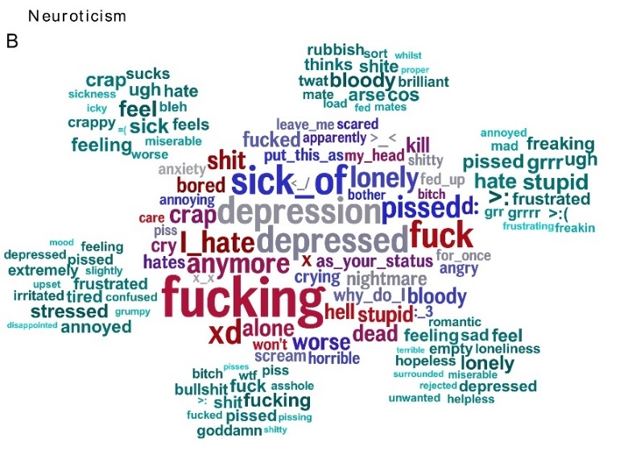
Figure 2.10 Word cloud indicating distinguishing linguistic features from people with high extraversion, introversion, emotional stability, and neuroticism.
(Source: Schwartz et al., 2013, p 12)

Predicting Personality Traits of Chinese Users Based on Facebook Wall Posts
This study was conducted by Peng et al. (2015, p. 9-14). The dataset used in this study was collected from 222 Facebook users who use Chinese as their main written language. Jieba, a Chinese text segmentation tool is used as the tokenizer for the task of text segmentation and SVM as the learning algorithm for personality classification. The generic procedure for the text classification in this study are as follows:

- Text feature extraction algorithms
The feature extraction procedure is divided into 3 steps: bag-of-words model, Chinese text segmentation, and weighted schemes.
- Bag-of-words model
Each text document in this model is viewed as a bag of words, discarding the word order and grammar. A corpus is viewed as a bag of N unique words. The result is a document-term matrix that is a text document represented by an N-dimension vector with the occurrence of a word as the value of each entry.
- Chinese text segmentation
Words in Chinese text cannot be easily delimited by computers, so an alternative tokenization method for Chinese textual data is needed. The “Jieba Chinese Text Segmentation” algorithm is used because it is the most suitable choice for the experiment in this study.
- Weighted schemes
In the term frequency (TF) weighted scheme, value of each entry in the document-term matrix represents the term frequency of each feature in a document. If a feature also occurs in many documents, that feature might be treated as a noise. To reduce the weight of a feature that occurs in many documents, the term frequency-inverse document frequency (TF-IDF) is used. TF-IDF is expected to eliminate noise or unimportant information in the data, so it can enlarge the representative features in each document.
- Feature selection algorithms
The feature selection algorithms used in this study are chi-squared test and the recursive feature elimination algorithm.
- Chi-squared test
There are several kinds of chi-squared tests used for different purposes. The Pearson’s chi-squared test is used in this study as the tests of independence between a feature and a label.
- Recursive feature elimination
The concept of RFE is to recursively construct a model and remove features with low weights until the desired number of selected features is reached.
- Classification algorithms
Support Vector Machine (SVM) is selected as the classification algorithm for this study. The goal of a SVM model is to find a hyperplane that can maximize the margin between two classes, to separate two classes as far as possible.
The data collection was done by obtaining a dataset with both Chinese text and personality scores of users. The personality scores are obtained from a general personality test, which is a short online questionnaire based on the Big Five Mini-Makers and TIPI (Ten Item Personality Inventory). The personality scores are measured by a 5-point scale ranging from 1 (strongly disagree) to 5 (strongly agree). Facebook identifier of each user was also obtained in order to collect the posts of each user.
The study was focused on the classification of extraversion which is most related to social activities in all the five dimensions of the Big Five model. For binary classification, the users with scores from 4 to 5 labeled as extraverts and users with scores from 1 to 3 labeled as introverts. The original dataset was randomly split into two groups: 90% of the dataset as a training set and the remaining as a testing set. Features for the training set was extracted by utilizing the Jieba Chinese text segmentation as tokenizer. The resulting text segments were dropped if occur only once in the entire corpus. The feature uncorrelated to the label classes was being filter out by a feature selection algorithm and the remaining ones were regarded as the features representing each document. A document-term matrix was constructed for the training set and the same features also used for the testing set. The open-source LIBSVM was used to classify the extraversion traits. The training set was used to come with a binary classifier for extraversion and then made predictions with that classifier for the testing set as the performance evaluation. The experiments were repeated ten times with the whole procedure to obtain the average performance for each performance metric.

Table 2.11 Average score of each personality
(Source: Peng et al., 2015, p. 3)
Personality | Average Score
Extraversion | 3.34
Neuroticism | 2.68
Agreeableness | 4.06
Conscientious | 3.19
Openness to Experience | 3.85

The overall average scores of personality show that the average scores of agreeableness and openness to experience are high. This might be due to sampling bias as most respondents are students or graduates from the same university and within the same age range.
The best accuracy of classifying extraversion is 73.5%, done by using the Jieba Chinese text segmentation as the tokenizer, the TF scheme for the representation of the document-term matrix, the X2-test as the feature selection algorithm, and the SVM as the learning algorithm.

Personality Classification Based on Twitter Text Using Naïve Bayes, KNN and SVM
This study is conducted by Pratama & Sarno (2015, p. 170-174). A personality prediction system was created in this study with an open-vocabulary approach. The system was created for 2 languages, namely Bahasa Indonesia and English.
There are 2 kinds of dataset used in this study. The first dataset is a Facebook dataset from myPersonality, which was used to train the system. The second dataset is a self-extracted Twitter dataset, which was utilized to test the system. In order to obtain a dataset in Bahasa Indonesia language, the authors translated the myPersonality dataset into Bahasa Indonesia.
The obtained dataset was put through a series of preprocessing tasks as follows.

- Tokenizing
Tokenization involves splitting the document into a single word.
- Stemming
Stemming replaces an affixed word to its base form by removing its morphological properties.
- Filtering
The filtering phase eliminates commonly used words in a language, or usually referred to as stop words.
- Weighting
Calculates the weighting for each word. The weighting used in this study is the TF-IDF weighting.
- Dataset instance reduction
The original myPersonality which consisted of 10,000 terms was further filtered to obtain the top 750 most frequently used word in the dataset. The purpose of this reduction is to reduce the load and processing time, while increasing the system’s efficiency and accuracy.
The personality prediction task in this study assumed that the task is a multi-label classification case, meaning one person can have more than one personality trait or no dominant personality trait at all. Thus, a classifier was built for each personality trait label, in which the classifier outputs a binary result. The study compares 3 different kinds of algorithms, namely the Naïve Bayes algorithm, K-Nearest Neighbor algorithm, and the Support Vector Machine algorithm. Details on the implementation of each algorithm are as follows.
- Naïve Bayes algorithm
A variation of the Naïve Bayes algorithm, the Multinomial Naïve Bayes (MNB) was implemented in this study. The MNB algorithm is designed to solve the task of text documents classification.
- K-Nearest Neighbor algorithm
The K-Nearest Neighbor (KNN) algorithm determines the class of an instance by using a distance function between the train data and the test data and the number of its nearest neighbors per class. The distance function used in this study is the cosine similarity function.
- Support Vector Machine algorithm
The Support Vector Machine (SVM) is a supervised learning classification algorithm which is used to recognize patterns in a dataset. An instance of the data is represented as a point in the feature space. An optimum hyperplane and 2 margins divide the 2 classes in the feature space, which determines which class the instance belongs to. The optimum hyperplane is determined using the following function.

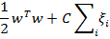
Figure 2.11 Optimum Hyperplane
(Source: Pratama & Sarno, 2015, p. 172)

The scoring function for the SVM algorithm is given below.

Figure 2.12 SVM Algorithm Scoring Function
(Source: Pratama & Sarno, 2015, p. 172)

Evaluation is done using 10-fold cross validation. Results showed that MNB achieved the best accuracy in the 3 algorithms tested with an average accuracy of 60%.

Table 2.12 Accuracy of English dataset
(Source: Pratama & Sarno, 2015, p. 173)
Accuracy | Multinomial Naïve Bayes | K-Nearest Neighbor | Support Vector Machine
Agreeableness | 61.33 ± 1.89 | 57.38 ± 1.67 | 61.88 ± 1.97
Conscientiousness | 62.87 ± 1.54 | 63.00 ± 1.68 | 60.75 ± 1.16
Extraversion | 57.75 ± 1.26 | 61.46 ± 2.11 | 59.99 ± 1.75
Neuroticism | 57.74 ± 1.9 | 52.25 ± 1.86 | 57.30 ± 1.29
Openness | 63.67 ± 1.54 | 64.92 ± 2.49 | 59.62 ± 1.54
Average | 60.63 ± 1.64 | 59.8 ± 1.98 | 59.62 ± 1.54

Table 2.13 Accuracy of Indonesian dataset
(Source: Pratama & Sarno, 2015, p. 173)
Accuracy | Multinomial Naïve Bayes | K-Nearest Neighbor | Support Vector Machine
Agreeableness | 63.21 ± 1.84 | 60.71 ± 2.48 | 62.95 ± 1.2
Conscientiousness | 58.67 ± 2.1 | 61.08 ± 3.19 | 60.35 ± 1.38
Extraversion | 51.5 ± 2.02 | 52.87 ± 2.03 | 53.21 ± 2.17
Neuroticism | 54.63 ± 2.01 | 54.0 ± 1.83 | 54.2 ± 2.14
Openness | 72.29 ± 2.13 | 62.83 ± 2.07 | 65.75 ± 1.69
Average | 60.06 ± 2.02 | 58.30 ± 2.37 | 59.29 ± 1.76

http://www.wjh.harvard.edu/~inquirer/
http://mypersonality.org/wiki/doku.php
http://mallet.cs.umass.edu/

